SHORT BIOGRAPHY OF PROF. DANIEL PRADEL, PE, GE, DGE

Dr. Daniel Pradel is Professor of Practice in the Civil, Environmental and Geodetic Engineering (CEGE) Dept. at The Ohio State University, where he teaches Geotechnical and Foundation Engineering at the graduate and undergraduate levels (CE3540, CE3541, CE5561 and CE5571). His research involves mainly the response of our civil engineering infrastructure (e.g., levees, dams, slopes, bridges, buildings, etc.) during extreme effects, including earthquakes, floods and hurricanes. Prior to joining OSU, he was Vice-President of Shannon & Wilson in California, and an Adjunct Associate Professor at UCLA where he taught for 28-years. He holds a Certificate of Postdoctoral Studies from UCLA, a Doctorate from the University of Tokyo, and a Diploma from the Swiss Institute of Technology in Lausanne (EPFL). Dr. Pradel is a registered Geotechnical Engineer in California and a registered Civil Engineer in several U.S. states and Europe. He has 30 years of practice in industry, and has worked on projects located in four continents, including large dams, landslide stabilizations, and multi-billion dollar transportation projects. He has performed numerous post-disaster reconnaissance visits after major natural hazard events in USA, Japan, and Nepal, including earthquakes, landslides and hurricanes. He is a Fellow of the American Society of Civil Engineers, a Diplomate of the Academy of Geo-Professionals, an Associate Editor of the American Society of Civil Engineers (ASCE) Journal of Geotechnical Engineering and Geo-Environmental Engineering, and a member of several ASCE and Deep Foundation Institute (DFI) technical committees.
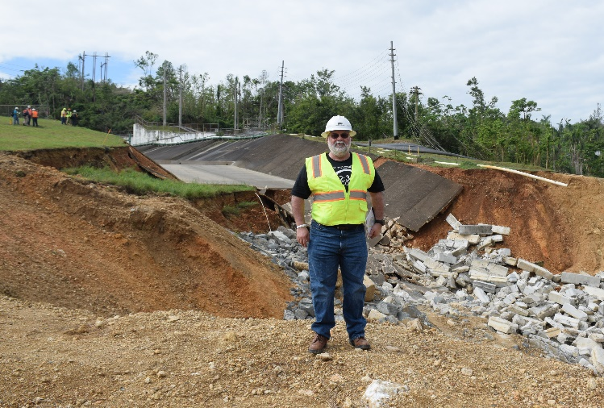
Left: Dr. Pradel next to building damaged by the April 2015 Gorkha (Nepal) Earthquake
Right: Dr. Pradel next to the damaged spillway of Guajataca Dam in Puerto Rico after hurricane Maria in 2018

